**Image and Video Processing**

EEE412

Lab4 - Report

Name: Cong Yin

ID Number: 1715471

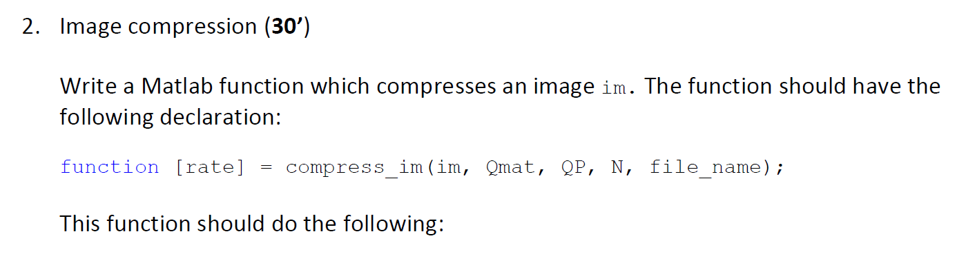

function [rate] = compress_im(im, Qmat, QP, N, file_name)

[m,n]=size(im);

Qmat=Qmat(1:N,1:N);

if QP>50

S=(100-QP)/50;

else

S=50/QP;

end

for i=1:N:m-(N-1)

for j=1:N:n-(N-1)

im_new=im(i:i+(N-1),j:j+(N-1));

im_dct=dct2(im_new);

im_quantization(i:i+(N-1),j:j+(N-1))=round(im_dct./(S*Qmat));

end

end

[vct_out] = entropy_enc(im_quantization);

csvwrite(file_name,vct_out)

size_f = fsize(file_name);

rate=(size_f*8)/(m*n);

im=imread('lenna512.bmp');

Qmat=[1,2,2,4,4,4,4,8,8,8,8,8,8,8,8,16;

2,2,2,4,4,4,4,8,8,8,8,8,8,8,8,16;

2,2,2,4,4,4,4,8,8,8,8,8,8,8,8,16;

4,4,4,4,4,4,4,8,8,8,8,8,8,8,8,16;

4,4,4,4,4,4,4,8,8,8,8,8,8,8,8,16;

4,4,4,4,4,4,4,8,8,8,8,8,8,8,8,16;

4,4,4,4,4,4,4,8,8,8,8,8,8,8,8,16;

8,8,8,8,8,8,8,8,8,8,8,8,8,8,8,16;

8,8,8,8,8,8,8,8,8,8,8,8,8,8,8,16;

8,8,8,8,8,8,8,8,8,8,8,8,8,8,8,16;

8,8,8,8,8,8,8,8,8,8,8,8,8,8,8,16;

8,8,8,8,8,8,8,8,8,8,8,8,8,8,8,16;

8,8,8,8,8,8,8,8,8,8,8,8,8,8,8,16;

8,8,8,8,8,8,8,8,8,8,8,8,8,8,8,16;

8,8,8,8,8,8,8,8,8,8,8,8,8,8,8,16;

16,16,16,16,16,16,16,16,16,16,16,16,16,16,16,16;];

N=8;

QP=50;

file_name='50.dat';

[rate] = compress_im(im, Qmat, QP, N, file_name);

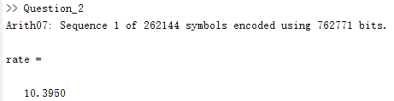

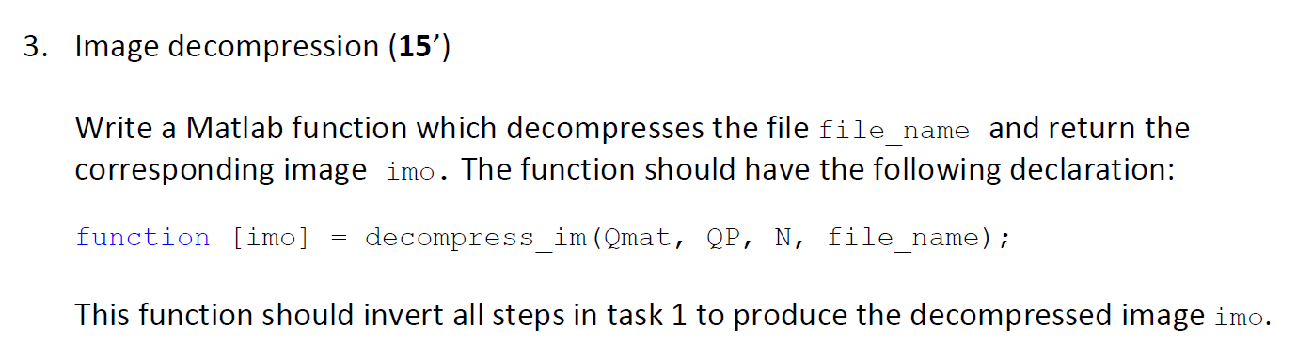

function [imo] = decompress_im(Qmat, QP, N, file_name)

Qmat=Qmat(1:N,1:N);

m=512;

n=512;

vct_in=csvread(file_name);

vct_out= entropy_dec(vct_in);

new=reshape(vct_out,[m n]);

if QP>50

S=(100-QP)/50;

else

S=50/QP;

end

for i=1:N:m-1

for j=1:N:n-1

im_dec=new(i:i+(N-1),j:j+(N-1));

im_dec_q=(S*Qmat).*im_dec;

imo(i:i+(N-1),j:j+(N-1))=idct2(im_dec_q);

end

end

imo=uint8(imo);

im=imread('lenna512.bmp');

load('50.dat')

Qmat=[1,2,2,4,4,4,4,8,8,8,8,8,8,8,8,16;

2,2,2,4,4,4,4,8,8,8,8,8,8,8,8,16;

2,2,2,4,4,4,4,8,8,8,8,8,8,8,8,16;

4,4,4,4,4,4,4,8,8,8,8,8,8,8,8,16;

4,4,4,4,4,4,4,8,8,8,8,8,8,8,8,16;

4,4,4,4,4,4,4,8,8,8,8,8,8,8,8,16;

4,4,4,4,4,4,4,8,8,8,8,8,8,8,8,16;

8,8,8,8,8,8,8,8,8,8,8,8,8,8,8,16;

8,8,8,8,8,8,8,8,8,8,8,8,8,8,8,16;

8,8,8,8,8,8,8,8,8,8,8,8,8,8,8,16;

8,8,8,8,8,8,8,8,8,8,8,8,8,8,8,16;

8,8,8,8,8,8,8,8,8,8,8,8,8,8,8,16;

8,8,8,8,8,8,8,8,8,8,8,8,8,8,8,16;

8,8,8,8,8,8,8,8,8,8,8,8,8,8,8,16;

8,8,8,8,8,8,8,8,8,8,8,8,8,8,8,16;

16,16,16,16,16,16,16,16,16,16,16,16,16,16,16,16;];

N=8;

QP=50;

file_name='50.dat';

[imo] = decompress_im(Qmat, QP, N, file_name);

subplot(1,2,1);imshow(im);title('original')

subplot(1,2,2);imshow(uint8(imo));title('decompress')

psnr = calculate_psnr(imo, im);

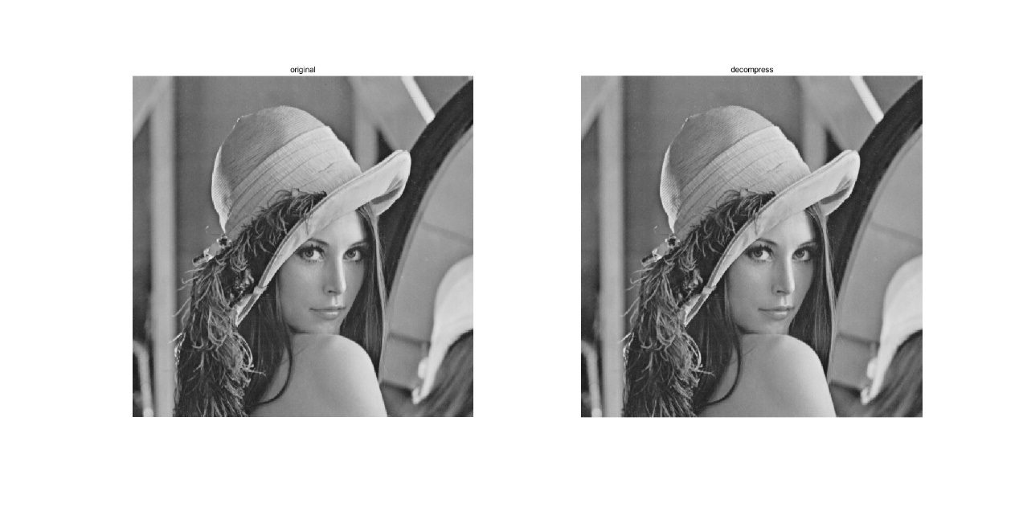

psnr =

45.2888

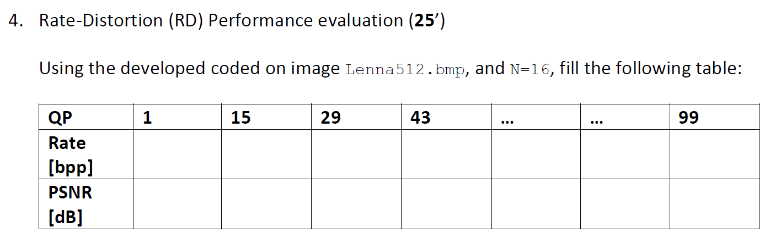

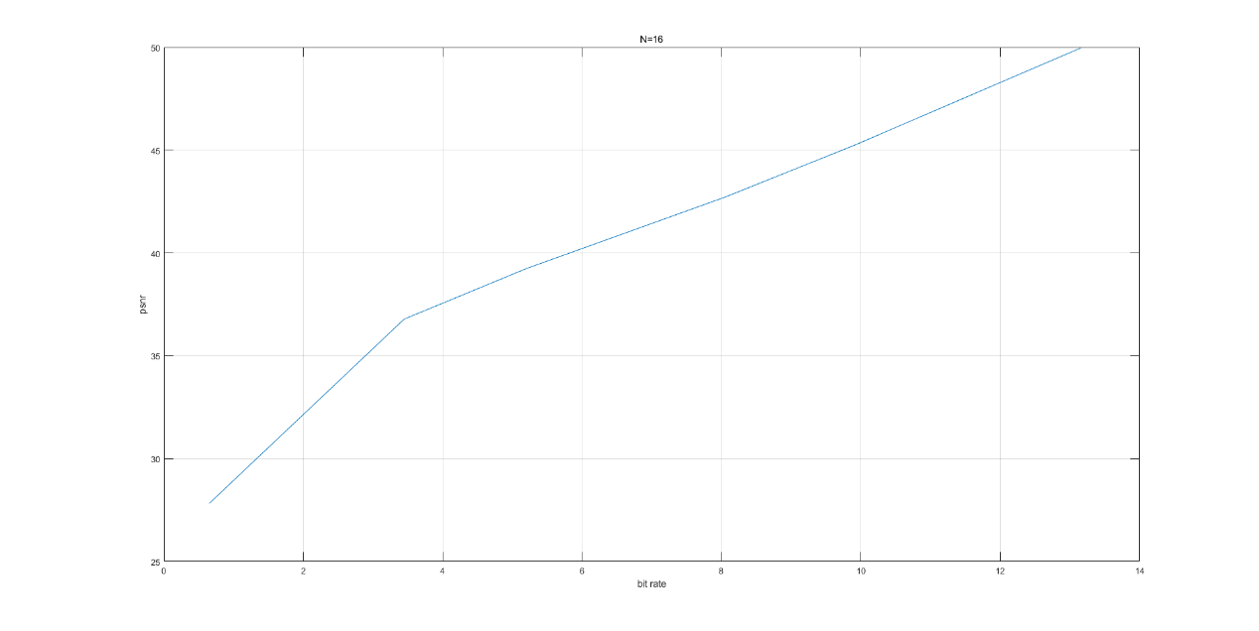

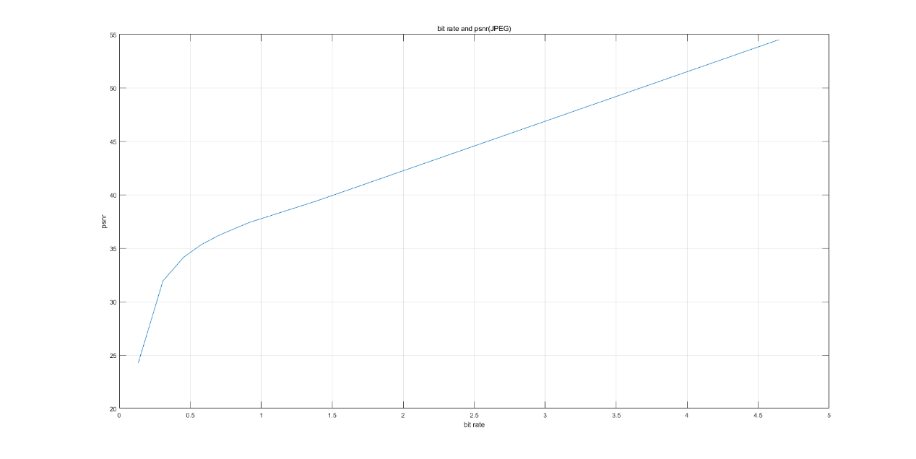

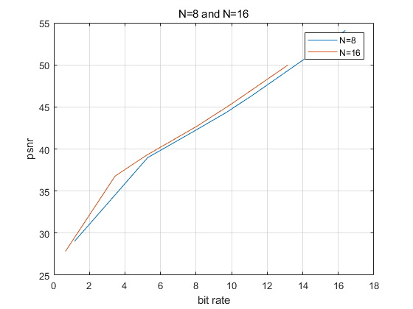

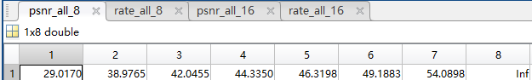

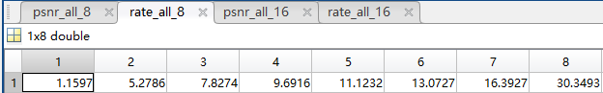

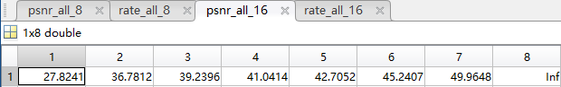

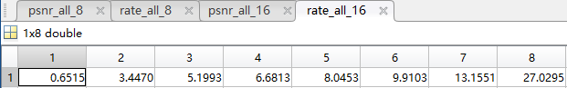

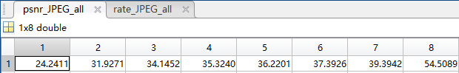

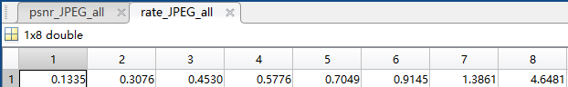

im=imread('lenna512.bmp');

Qmat=[1,2,2,4,4,4,4,8,8,8,8,8,8,8,8,16;

2,2,2,4,4,4,4,8,8,8,8,8,8,8,8,16;

2,2,2,4,4,4,4,8,8,8,8,8,8,8,8,16;

4,4,4,4,4,4,4,8,8,8,8,8,8,8,8,16;

4,4,4,4,4,4,4,8,8,8,8,8,8,8,8,16;

4,4,4,4,4,4,4,8,8,8,8,8,8,8,8,16;

4,4,4,4,4,4,4,8,8,8,8,8,8,8,8,16;

8,8,8,8,8,8,8,8,8,8,8,8,8,8,8,16;

8,8,8,8,8,8,8,8,8,8,8,8,8,8,8,16;

8,8,8,8,8,8,8,8,8,8,8,8,8,8,8,16;

8,8,8,8,8,8,8,8,8,8,8,8,8,8,8,16;

8,8,8,8,8,8,8,8,8,8,8,8,8,8,8,16;

8,8,8,8,8,8,8,8,8,8,8,8,8,8,8,16;

8,8,8,8,8,8,8,8,8,8,8,8,8,8,8,16;

8,8,8,8,8,8,8,8,8,8,8,8,8,8,8,16;

16,16,16,16,16,16,16,16,16,16,16,16,16,16,16,16;];

file_name_8='Question4_2.dat';

file_name_16='Question4_2.dat';

N_8=8;

N_16=16;

i=1;

k=1;

for QP_8=1:14:99

rate_8 = compress_im(im, Qmat, QP_8, N_8, file_name_8);

imo_8 = decompress_im(Qmat, QP_8, N_8 , file_name_8);

psnr_8 = calculate_psnr(imo_8, im);

rate_all_8(i)=rate_8;

psnr_all_8(i)=psnr_8;

i=i+1;

end

for QP_16=1:14:99

rate_16 = compress_im(im, Qmat, QP_16, N_16, file_name_16);

imo_16 = decompress_im(Qmat, QP_16, N_16 , file_name_16);

psnr_16 = calculate_psnr(imo_16, im);

rate_all_16(k)=rate_16;

psnr_all_16(k)=psnr_16;

k=k+1;

end

plot(rate_all_8,psnr_all_8,rate_all_16,psnr_all_16);

legend('N=8','N=16')

xlabel('bit rate');

ylabel('psnr')

title('N=8 and N=16');

grid on;

im=imread('lenna512.bmp');

file_name_JPEG='Question4_JPEG.dat';

i=1;

for QP=1:14:99

imwrite(im,file_name_JPEG,'jpeg','Quality',QP);

imo_JPEG=imread('Question4_JPEG.dat');

[size_JPEG]=fsize(file_name_JPEG);

rate_JPEG=(size_JPEG*8)/(512^2);

psnr_JPEG = calculate_psnr(imo_JPEG, im);

rate_JPEG_all(i)=rate_JPEG;

psnr_JPEG_all(i)=psnr_JPEG;

i=i+1;

end

figure,plot(rate_JPEG_all,psnr_JPEG_all);

xlabel('bit rate');

ylabel('psnr');

title('bit rate and psnr(JPEG)');

grid on;